Problem Statement
Mobile operators offer many prepaid plans, each with a different price, validity, data allowance and call minutes. If a user goes over a plan’s limits, excess charges are added. A plan that looks cheap can turn out costly once those extra charges are included, and a plan may not last as long as the user needs.
Objectives
- Store plans as tuples and the user’s needs as a dictionary.
- Calculate excess data and call charges for each plan.
- Check eligibility (validity and budget) for each plan.
- Compare the total cost (price + excess) of all eligible plans.
- Display a comparison table and recommend the best plan.
Assumptions
- Each plan is a tuple: (name, price, validity_days, data_gb, call_minutes, extra_per_gb, extra_per_min).
- Prices are in rupees (Rs).
- Usage is the user’s total data (GB) and call minutes over the period they need, plus the number of days the plan must last.
- Total cost = plan price + excess charges.
- Excess data charge = (usage − plan data) × rate per GB, if usage is more than the plan’s data. Call minutes work the same way.
- A plan is eligible only if its validity is at least the days needed and its total cost is within the budget.
- If two plans have the same total cost, the one with the lower base price wins.
- SMS and taxes are ignored to keep things simple.
Algorithm
- Define the list of plans, the user’s usage and the budget.
- For each plan, calculate the excess data and excess minutes (zero if within limits).
- Excess charge = extra data × rate per GB + extra minutes × rate per minute.
- Total cost = price + excess charge.
- Check validity. If it is shorter than the days needed, mark the plan “validity too short”.
- Check budget. If the total cost is more than the budget, mark it “over budget”.
- Otherwise mark it “eligible”.
- Among eligible plans, pick the one with the lowest total cost.
- If there are no eligible plans, report that no plan fits.
Pseudocode
FUNCTION calculate_excess(plan, usage):
extra_data = MAX(0, usage.data - plan.data)
extra_minutes = MAX(0, usage.minutes - plan.minutes)
RETURN extra_data * plan.per_gb + extra_minutes * plan.per_min

FUNCTION check_eligibility(plan, usage, budget):
total = plan.price + calculate_excess(plan, usage)
IF plan.validity < usage.days: RETURN False, total, "validity too short"
IF total > budget: RETURN False, total, "over budget"
RETURN True, total, "eligible"

FUNCTION best_plan(results):
eligible = results that are eligible
IF eligible is empty: RETURN None
RETURN plan with the smallest total (ties: smaller price)

MAIN:
FOR each plan in plans:
evaluate the plan and store the result
best = best_plan(results)
print table and best plan
Test Cases
# | Test | Input | Expected result
1 | No excess | Basic plan, usage 20 GB / 50 min | Excess = 0
2 | Excess on both | Basic plan, usage 30 GB / 120 min | Excess = 2×10 + 20×1 = 40
3 | Validity too short | Basic (28 days), need 30 days | Not eligible: validity too short
4 | Over budget | Basic, budget 150 | Not eligible: over budget
5 | Exactly on budget | Basic, budget 199 | Eligible
6 | No plan fits | Budget 100 | best_plan returns None
7 | Excess beats low price | Plan A (Rs 300, small limits) vs Plan B (Rs 199) | Plan B chosen
8 | Main example | Usage 40 GB / 150 min / 28 days, budget 450 | Best plan = Value (Rs 299)
Output
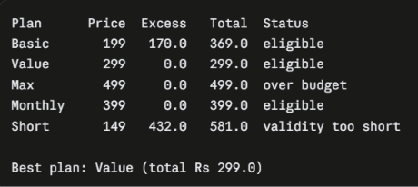
Flowchart
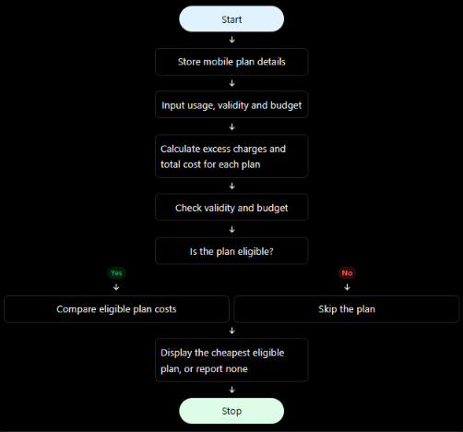
Conclusion
The program compares several mobile plans against the user’s data, call usage, validity need and budget. It calculates excess charges, filters out plans that fail the validity or budget rules, and recommends the eligible plan with the lowest total cost. In the sample run, Value at Rs 299 wins. The cheapest base plan, Basic, costs Rs 369 once excess charges are added, and Max is over budget.

